**Experiment Title 2**

**Student Name: Husanpreet Kaur UID: 20BCS9512**

**Branch: BE-CSE Section/Group: 20BCS-DM-714/A**

**Semester: 6 Subject Code: 20CSP-376**

**Subject Name: Data Mining Lab Date of Performance: 09-03-2023**

1. **Aim/Overview of the practical:** To perform the statistical analysis of data.
2. **Tools used:** RStudio and RWeka
3. **Code:**

**Creating_arrf_file.R:**

library(RWeka)

setwd("C:\\Users\\hp\\Documents\\DATA MINING CODES\\EXPERIMENT 2")

getwd()

rating <- 1:4

animal <- c('koala', 'hedgehog', 'sloth', 'panda')

country <- c('Australia', 'Italy', 'Peru', 'China')

avg_sleep_hours <- c(21, 18, 17, 10)

super_sleepers <- data.frame(rating, animal, country, avg_sleep_hours, stringAsFactors=FALSE)

print(super_sleepers)

print(class(super_sleepers))

print(str(super_sleepers))

write.arff(super_sleepers, file="super_sleepers.arff")

**Experiment2.R:**

library("RWeka")

N = read.arff("super_sleepers.arff")

print(N)

cat("\n\n\n")

print(head(N,2))

dim(N)

names(N)

N["animal"]

N["avg_sleep_hours"]

max(N["avg_sleep_hours"])

min(avg_sleep_hours)

sum(avg_sleep_hours)

mean(avg_sleep_hours)

median(sort(avg_sleep_hours))

sd(avg_sleep_hours)

summary(N)

1. **Output:**

RStudio:

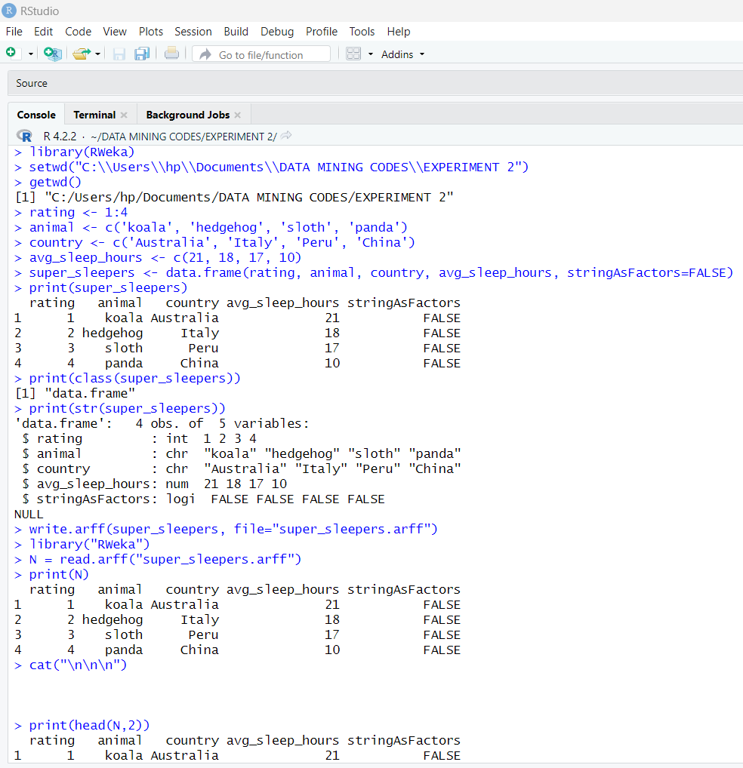

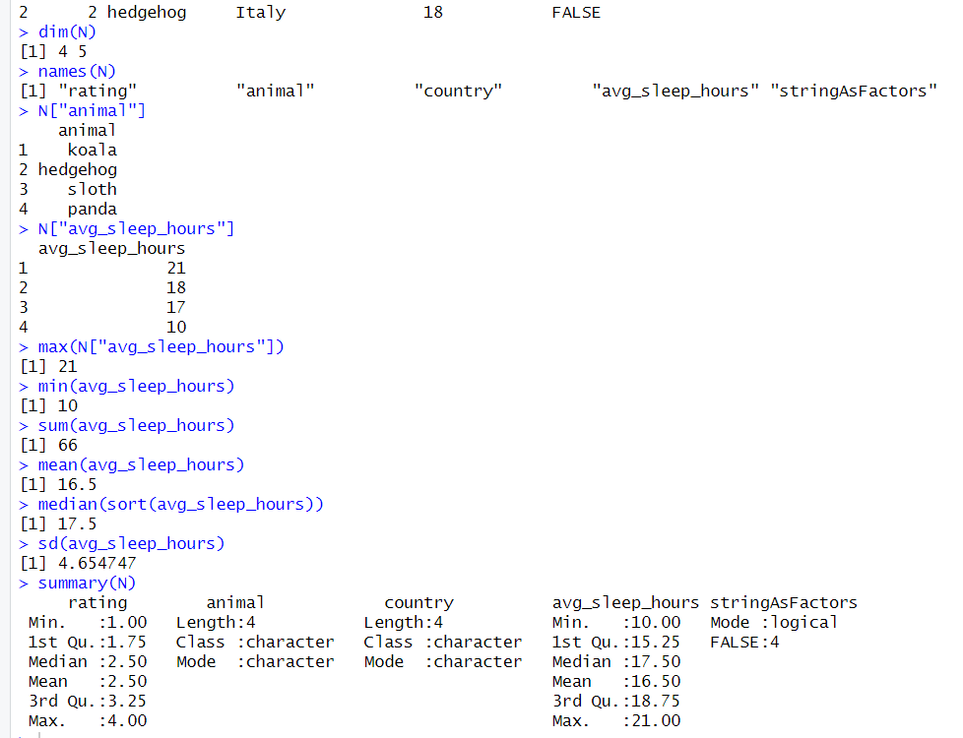

Files: 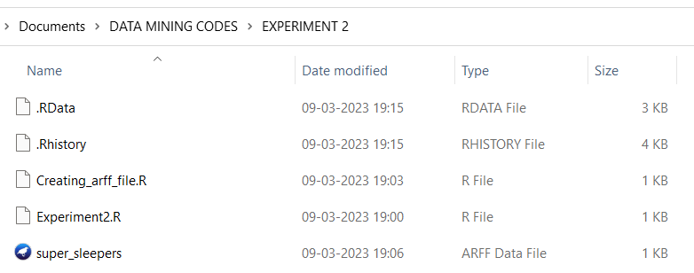

Weka:

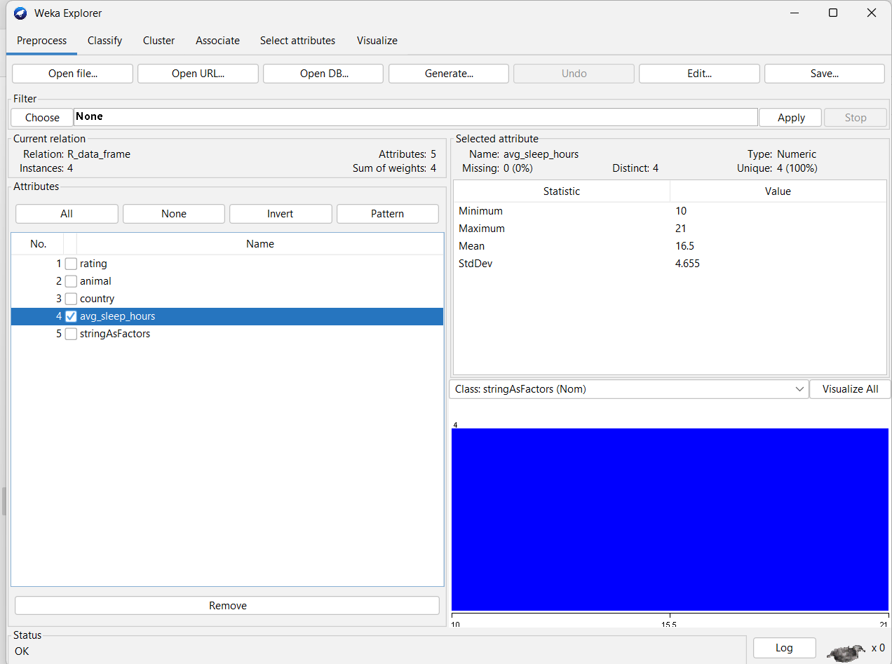

1. **Observation:**

* Learnt how to use R and create a file in Rstudio.
* Learnt how to import files in weka.
* Learnt about different methods like setwd() and getwd()
* Learnt about statistical methods and their usage.